|  |  |
| --- | --- |
| KSU_logo.jpg | **King Saud University**  **College of Computer and Information Sciences**  **Department of Computer Science** |

**CSC 220: Computer Organization**

**Labwork - 7#**

1. **Introduction.**

Today we are going to design sequential circuits By D Latch with x.y inputs. Z is the output.

1. **Experiments.**

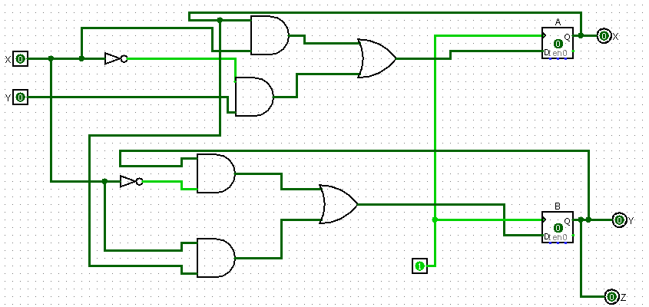

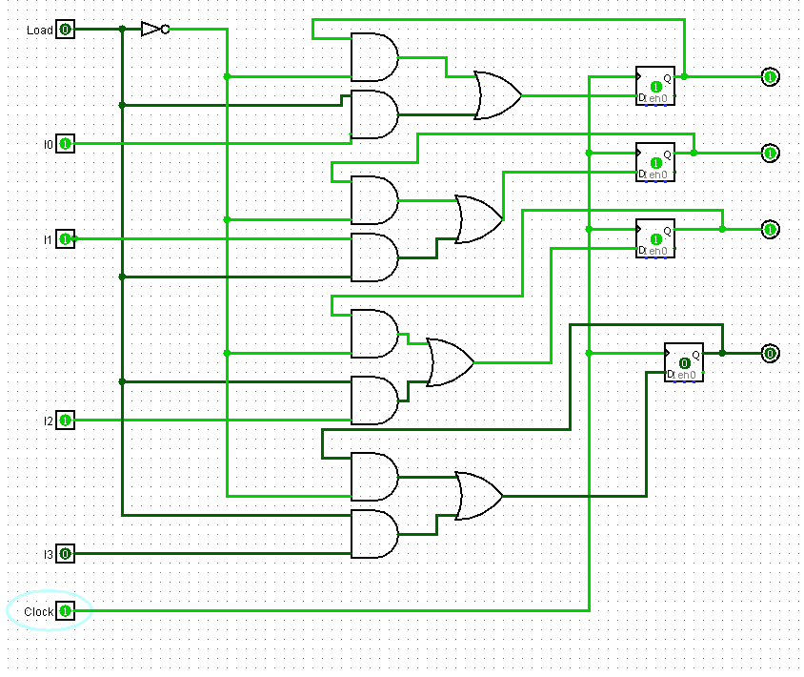

1. **Results.**

|  |  |  |  |  |
| --- | --- | --- | --- | --- |
| **X** | **y** | **Z** | **Da** | **Db** |
| **0** | **0** | **0** | **0** | **0** |
| **0** | **0** | **1** | **0** | **0** |
| **0** | **1** | **0** | **1** | **1** |
| **0** | **1** | **1** | **1** | **1** |
| **1** | **0** | **0** | **0** | **0** |
| **1** | **0** | **1** | **1** | **1** |
| **1** | **1** | **0** | **0** | **0** |
| **1** | **1** | **1** | **1** | **1** |

1. **Discussion.**

In Exp1, After we draw the Circuits, we found the two Function(Da,Db) will be the same result.

In the Exp2 if load is 0 there are no change, if it is 1 its depends about Inputs and present state.